May 10-12
District Assembly
Sheraton Hotel, Parsippany

Fri-Sun, May 18-20
“You’re Still the One” Marriage Retreat
Spruce Lake Lodge, PA

June 2
Bonfire Worship
7:00pm

June 10
Baptism Class

June 24
V.I.P Meeting (Vision, Inspiration, Prayer)
6:30-8:30pm

July 8
Baptism & Church Family Picnic
7:00am

Fri-Sun, Oct 12-14
Church Family Retreat
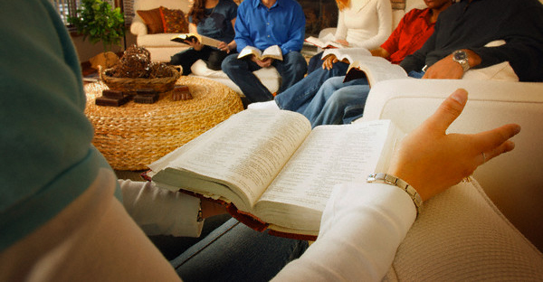
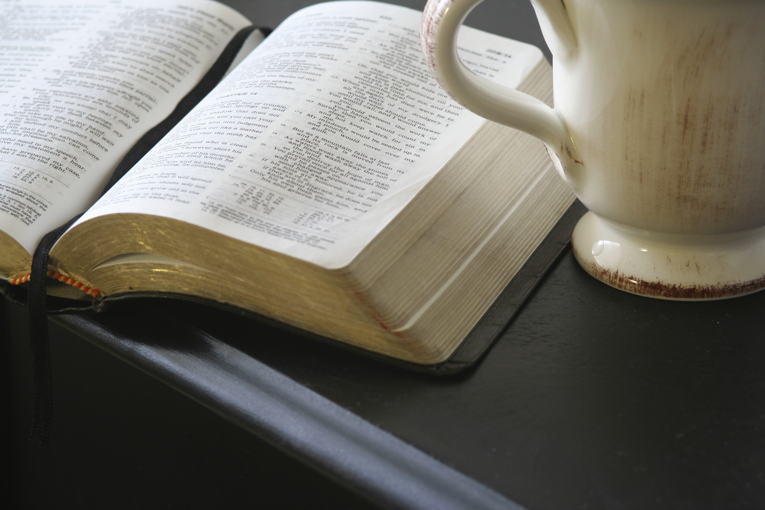
Spruce Lake Lodge, PA
Trumpets have a significant history in the Old Testament. The blowing of a trumpet:
1. Initiates battles
2. Calls people to celebration
3. Announces the coming of a king.
There are three “judgments” of seven: Seven seals, seven trumpets and seven bowls. Each one is taking a different perspective of God’s work in the world as it relates to the seven churches in Revelation. Remember, this is a letter, a pastoral epistle from John to help these churches through their suffering and persecution. He continues, with these images, to encourage them to never give up and never compromise.
We soon realize that these trumpets are the response to the prayers of the saints in chapter 6. Even when there seems to be no action and no word from God, He is working. Through the eyes of faith we patiently wait as God work. One day He will establish His kingdom and renew heaven and earth.

KEY POINTS
1. The end of the story is “God wins.”
2. Prayer is working even when we don’t see any results. Although there seems to be a lot of tumult God is still at work.
3. The trumpets announce God’s coming and ultimately He will reign.

Trumpets

Revelation Chapter 8 - 9:
Spring 2018
April 11, 2018
  - April 11, 2018

Small Group
Revelation 8 & 9

1. The first trumpet is the response (chapter 8) to the prayers of the martyrs (chapter 6):
⁹ When he opened the fifth seal, I saw under the altar the souls of those who had been slain because of the word of God and the testimony they had maintained.¹⁰ They called out in a loud voice, “How long, Sovereign Lord, holy and true, until you judge the inhabitants of the earth and avenge our blood?” ¹¹ Then each of them was given a white robe, and they were told to wait a little longer, until the full number of their fellow servants, their brothers and sisters, were killed just as they had been……….

1 When he opened the seventh seal, there was silence in heaven for about half an hour.² And I saw the seven angels who stand before God, and seven trumpets were given to them.³ Another angel, who had a golden censer, came and stood at the altar. He was given much incense to offer, with the prayers of all God’s people, on the golden altar in front of the throne. ⁴ The smoke of the incense, together with the prayers of God’s people, went up before God from the angel’s hand. ⁵ Then the angel took the censer, filled it with fire from the altar, and hurled it on the earth; and there came peals of thunder, rumblings, flashes of lightning and an earthquake.
What is the word of instruction that John is giving to the Churches who are being persecuted? Discuss their cry of “how long?”

2. The images of the trumpets are disturbing. Mass destruction. Death, disease and pestilence throughout the earth. But, in each case only 1/3 of (earth, trees, grass, sea, sea creatures, ships, rivers, stars, etc.) are destroyed, leaving 2/3 intact. What do you believe is the meaning of this as it relates to the churches of Revelation? What is the meaning of this as it relates to all of God’s church throughout all of history?

3. After all of this destruction, mankind is unchanged. They still refuse to repent. They still worship the idols of gold and silver.
²⁰ The rest of mankind who were not killed by these plagues still did not repent of the work of their hands; they did not stop worshiping demons, and idols of gold, silver, bronze, stone and wood—idols that cannot see or hear or walk. ²¹ Nor did they repent of their murders, their magic arts, their sexual immorality or their thefts. (9:20-21)

What does this say about the worship of money, power and prestige? What “idols” do we face in the world today?

Does terror, judgment, massive destruction really lead to broad repentance? What was the lasting effect (in terms of repentance and revival) after such tragedies as the atomic bomb, 9/11 or the great Indonesian tsunami in 2004?

Bible Study Questions

1. How do you deal with unanswered prayer? Discuss how you deal with “waiting” when it comes to prayer.
2. The 7th trumpet announces that God will rein forever and ever (chapter 11:15 – 19; printed on the next page)
a. Discuss what emotions you have when you read these words or hear the music from Handel’s Messiah (The Hallelujah Chorus).
b. What does verse 18 mean to you when it indicates that those who destroy the earth will be destroyed? .
3. We are taking a Literary/Analytic/-Spiritual approach to interpreting Revelation (spiritual realities of conflicts between good and evil throughout the ages) as opposed to Historicist (historical events throughout history described) Preterist (events in Revelation have all been fulfilled in the past) or Futurist (events described will happen in the future, mostly after the rapture, at the end of time).
a. How does the Spiritual approach differ from your experience?
b. Have you learned anything different form this perspective?

Please answer the questions below as they best apply to you personally. Speak in the “I”. There is no obligation to answer any question.
Personal Application Questions
¹⁵ The seventh angel sounded his trumpet, and there were loud voices in heaven, which said:
“The kingdom of the world has become
the kingdom of our Lord and of his Messiah,
and he will reign for ever and ever.”
¹⁶ And the twenty-four elders, who were seated on their thrones before God, fell on their faces and worshiped God, ¹⁷ saying:
“We give thanks to you, Lord God Almighty,
the One who is and who was,
because you have taken your great power
and have begun to reign.
¹⁸ The nations were angry,
and your wrath has come.
The time has come for judging the dead,
and for rewarding your servants the prophets
and your people who revere your name,
both great and small—
and for destroying those who destroy the earth.”
¹⁹ Then God’s temple in heaven was opened, and within his temple was seen the ark of his covenant. And there came flashes of lightning, rumblings, peals of thunder, an earthquake and a severe hailstorm.

.
Revelation 8&9

